Felzenswalb Segmentation Output:

Source Image: Berlin HyMap01 data (500:800, 800:1100,0:3)
Band used: 3
Min component size: 20
Threshold c: 500
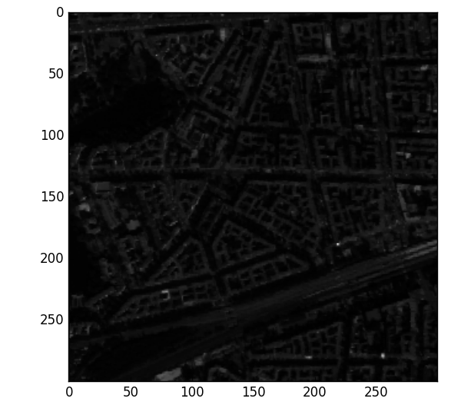

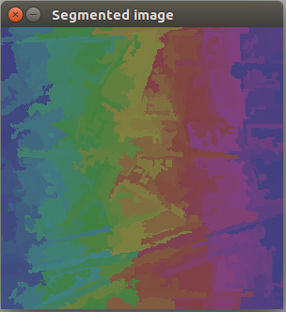
Segmented Image

Source Image: Berlin HyMap01 data (500:800, 800:1000, 0:5)
Band used: 5
Min component size: 50
Threshold c: 200, 500, 800

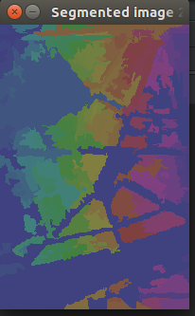
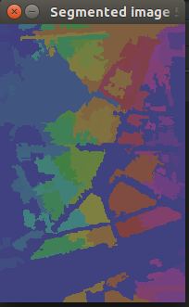
c=200 c= 500
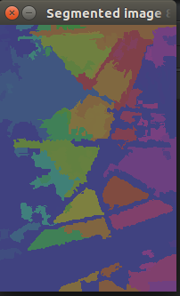

c=800

